1. Download and install Java - <https://www.oracle.com/technetwork/java/javase/downloads/jdk10-downloads-4416644.html>
2. Download and install Maven - <https://maven.apache.org/download.cgi>
3. Download and install Tomcat 9 - <https://tomcat.apache.org/download-90.cgi>
4. Checkout “master” in git - git remote add -t master -f origin <https://github.com/kc2coast/TicketAdvantage.git>
5. Build code at the base directory pom.xml – mvn clean; mvn install
6. Download and install Postgresql - <https://www.postgresql.org/download>
7. Download and install Eclipse Photon - <https://www.eclipse.org/downloads/>
8. Setup projects in Eclipse
   1. Select workspace

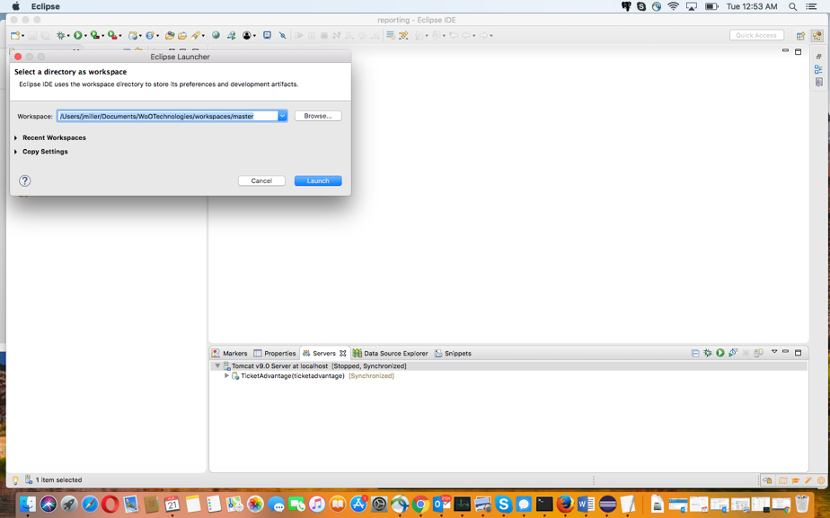

* 1. Import existing maven project

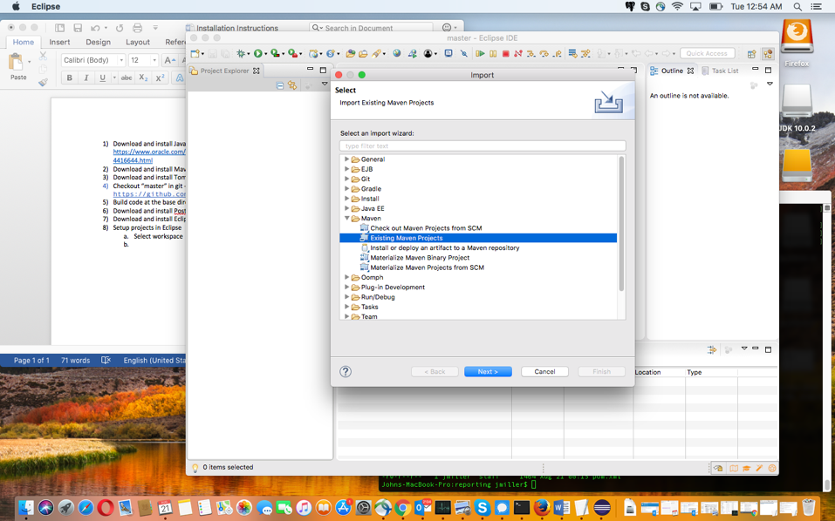

* 1. Import Maven Projects

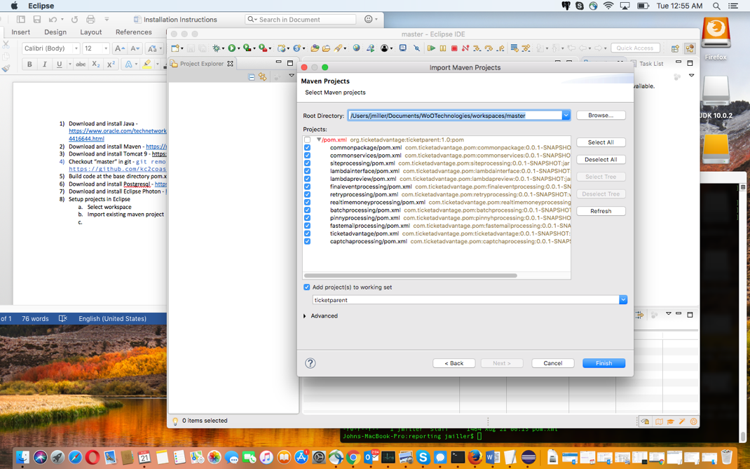

* 1. Setup Tomcat Server

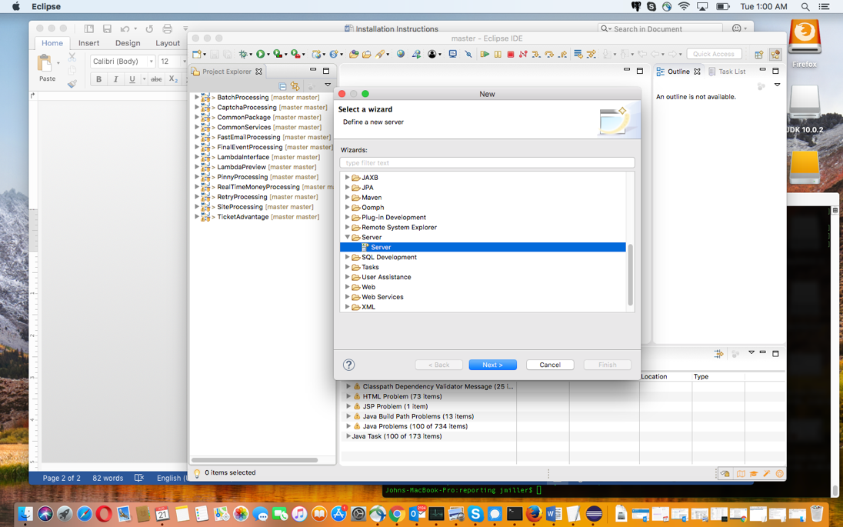

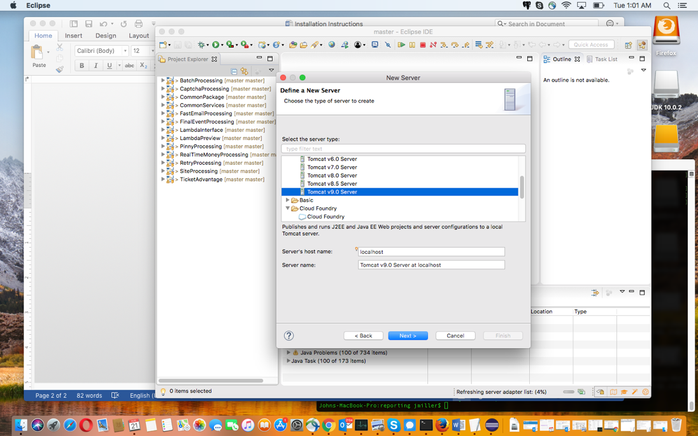

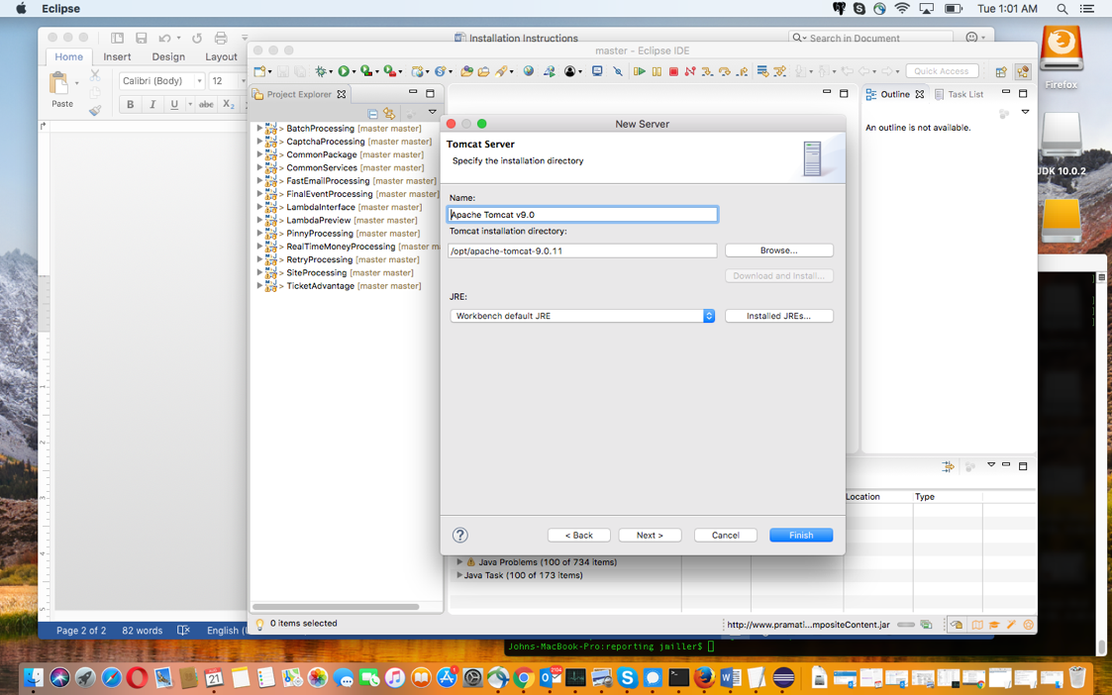

1. Hjhj